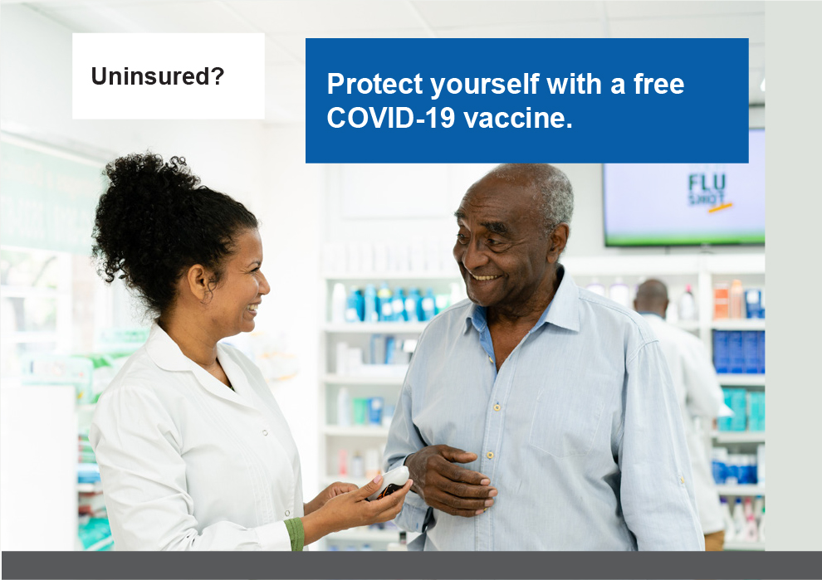

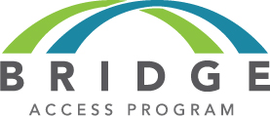


The Bridge Access Program provides free updated COVID-19 vaccines for any adult 18 years or older without health insurance or whose plan doesn’t fully cover COVID-19 vaccination. You don′t need to sign up. Just tell a participating provider whether you have coverage.
Find a free COVID-19 vaccine near you at Vaccines.gov.
The Bridge Access Program provides free updated COVID-19 vaccines for any adult 18 years or older without health insurance or whose plan doesn’t fully cover COVID-19 vaccination. You don′t need to sign up. Just tell a participating provider whether you have coverage.
Find a free COVID-19 vaccine near you at Vaccines.gov.

